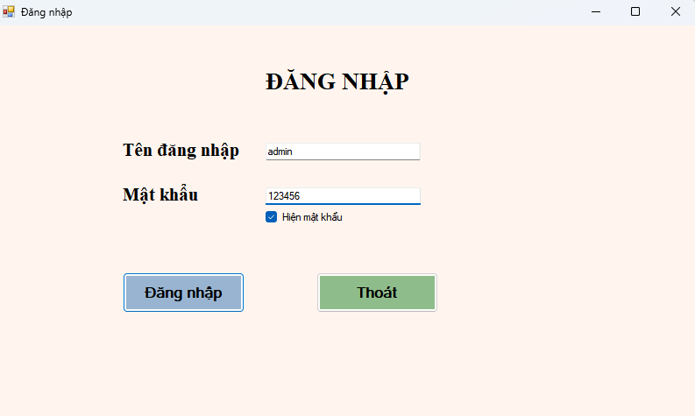
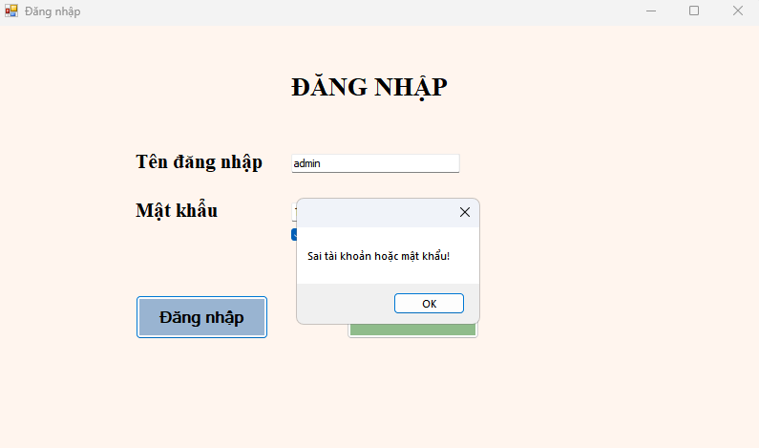
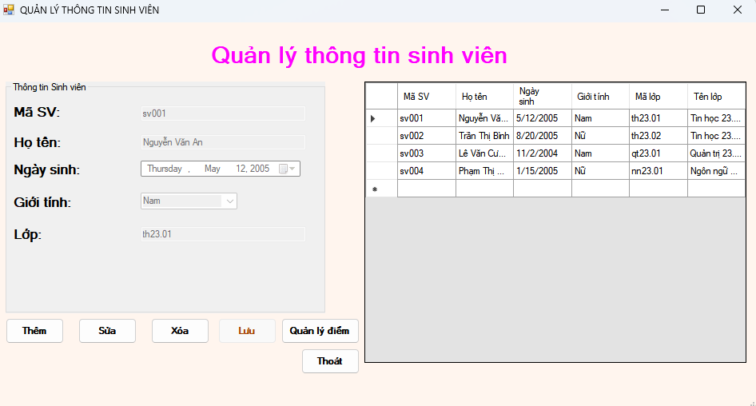
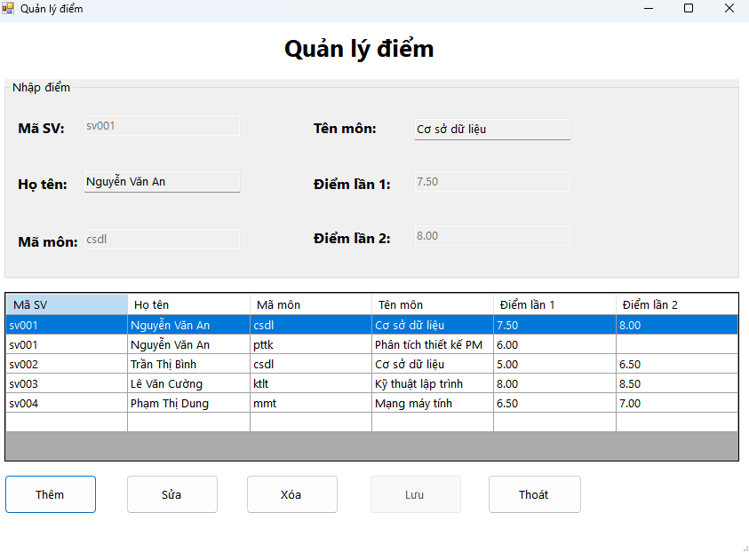

CODE ĐĂNG NHẬP
Imports System.Data.SqlClient

Public Class frmLogin
Private ReadOnly connStr As String =
"Data Source=ADMIN-PC\SQLEXPRESS;Initial Catalog=quanlysinhvien;Integrated Security=True;TrustServerCertificate=True"

Private Sub frmLogin_Load(sender As Object, e As EventArgs) Handles MyBase.Load
Me.StartPosition = FormStartPosition.CenterScreen
Me.AcceptButton = btnLogin
Me.CancelButton = btnThoat

' Quan trọng: bỏ PasswordChar để UseSystemPasswordChar có hiệu lực
txtPass.PasswordChar = ControlChars.NullChar
txtPass.UseSystemPasswordChar = Not chkShow.Checked
End Sub

Private Sub chkShow_CheckedChanged(sender As Object, e As EventArgs) Handles chkShow.CheckedChanged
If chkShow.Checked Then
' Hiện mật khẩu
txtPass.PasswordChar = ControlChars.NullChar
txtPass.UseSystemPasswordChar = False
Else
' Ẩn mật khẩu (ký tự hệ thống •)
txtPass.PasswordChar = ControlChars.NullChar
txtPass.UseSystemPasswordChar = True
End If
End Sub

Private Sub btnLogin_Click(sender As Object, e As EventArgs) Handles btnLogin.Click
If String.IsNullOrWhiteSpace(txtUser.Text) OrElse String.IsNullOrWhiteSpace(txtPass.Text) Then
MessageBox.Show("Vui lòng nhập tên đăng nhập và mật khẩu!")
Return
End If

Using cn As New SqlConnection(connStr),
cmd As New SqlCommand("SELECT COUNT(*) FROM nguoidung WHERE username=@u AND password=@p", cn)
cmd.Parameters.AddWithValue("@u", txtUser.Text.Trim())
cmd.Parameters.AddWithValue("@p", txtPass.Text.Trim())
cn.Open()
Dim n As Integer = CInt(cmd.ExecuteScalar())
If n > 0 Then
Dim f As New frmSinhVien()
Me.Hide()
f.StartPosition = FormStartPosition.CenterScreen
f.ShowDialog()
Me.Close()
Else
MessageBox.Show("Sai tài khoản hoặc mật khẩu!")
End If
End Using
End Sub

Private Sub btnThoat_Click(sender As Object, e As EventArgs) Handles btnThoat.Click
Me.Close()
End Sub
End Class

CODE QUẢN LÝ THÔNG TIN SINH VIÊN
Imports System.Data
Imports System.Data.SqlClient

Public Class frmSinhVien

Private _mode As String = "VIEW"

Private Function GetConn() As SqlConnection
Return New SqlConnection("Data Source=ADMIN-PC\SQLEXPRESS;Initial Catalog=quanlysinhvien;Integrated Security=True;TrustServerCertificate=True")
End Function

Private Function GetDataTable(sql As String, Optional pars As List(Of SqlParameter) = Nothing) As DataTable
Dim dt As New DataTable()
Using cn = GetConn(), cmd As New SqlCommand(sql, cn)
If pars IsNot Nothing Then cmd.Parameters.AddRange(pars.ToArray())
Using da As New SqlDataAdapter(cmd)
da.Fill(dt)
End Using
End Using
Return dt
End Function

Private Function ExecNonQuery(sql As String, Optional pars As List(Of SqlParameter) = Nothing) As Integer
Using cn = GetConn(), cmd As New SqlCommand(sql, cn)
If pars IsNot Nothing Then cmd.Parameters.AddRange(pars.ToArray())
cn.Open()
Return cmd.ExecuteNonQuery()
End Using
End Function

Private Function ExecScalar(Of T)(sql As String, Optional pars As List(Of SqlParameter) = Nothing) As T
Using cn = GetConn(), cmd As New SqlCommand(sql, cn)
If pars IsNot Nothing Then cmd.Parameters.AddRange(pars.ToArray())
cn.Open()
Dim o = cmd.ExecuteScalar()
If o Is Nothing OrElse o Is DBNull.Value Then Return Nothing
Return CType(o, T)
End Using
End Function

Private Sub frmSinhVien_Load(sender As Object, e As EventArgs) Handles MyBase.Load
cboGioiTinh.Items.Clear()
cboGioiTinh.Items.AddRange(New String() {"Nam", "Nữ"})
If cboGioiTinh.Items.Count > 0 Then cboGioiTinh.SelectedIndex = 0
dtpNgaySinh.MaxDate = Date.Today
LoadGrid()
SetMode("VIEW")
End Sub

Private Sub LoadGrid(Optional keyword As String = "")
Dim sql As String =
"SELECT sv.masv, sv.hoten, sv.ngaysinh, sv.gioitinh, sv.malop, ISNULL(l.tenlop,'') AS tenlop
FROM sinhvien sv
LEFT JOIN lop l ON sv.malop = l.malop"

Dim pars As New List(Of SqlParameter)
If Not String.IsNullOrWhiteSpace(keyword) Then
sql &= " WHERE sv.masv LIKE @kw OR sv.hoten LIKE @kw OR sv.malop LIKE @kw OR l.tenlop LIKE @kw"
pars.Add(New SqlParameter("@kw", "%" & keyword & "%"))
End If
sql &= " ORDER BY sv.masv"

Dim dt = GetDataTable(sql, pars)
dgvSinhVien.DataSource = dt

If dgvSinhVien.Columns.Count > 0 Then
dgvSinhVien.Columns("masv").HeaderText = "Mã SV"
dgvSinhVien.Columns("hoten").HeaderText = "Họ tên"
dgvSinhVien.Columns("ngaysinh").HeaderText = "Ngày sinh"
dgvSinhVien.Columns("gioitinh").HeaderText = "Giới tính"
dgvSinhVien.Columns("malop").HeaderText = "Mã lớp"
dgvSinhVien.Columns("tenlop").HeaderText = "Tên lớp"
dgvSinhVien.AutoSizeColumnsMode = DataGridViewAutoSizeColumnsMode.Fill
dgvSinhVien.ReadOnly = True
dgvSinhVien.SelectionMode = DataGridViewSelectionMode.FullRowSelect
dgvSinhVien.MultiSelect = False
End If
End Sub

Private Sub SetMode(mode As String)
_mode = mode
Dim editing As Boolean = (mode = "ADD" OrElse mode = "EDIT")

txtMaSV.Enabled = (mode = "ADD")
txtHoTen.Enabled = editing
dtpNgaySinh.Enabled = editing
cboGioiTinh.Enabled = editing
txtLop.Enabled = editing

btnThem.Enabled = (mode = "VIEW")
btnSua.Enabled = (mode = "VIEW" AndAlso dgvSinhVien.CurrentRow IsNot Nothing)
btnXoa.Enabled = (mode = "VIEW" AndAlso dgvSinhVien.CurrentRow IsNot Nothing)
btnLuu.Enabled = editing
btnThoat.Enabled = True
End Sub

Private Sub ClearInputs()
txtMaSV.Clear()
txtHoTen.Clear()
txtLop.Clear()
dtpNgaySinh.Value = Date.Today
If cboGioiTinh.Items.Count > 0 Then cboGioiTinh.SelectedIndex = 0
End Sub

Private Function ValidateInputs() As Boolean
If String.IsNullOrWhiteSpace(txtMaSV.Text) Then MessageBox.Show("Vui lòng nhập Mã SV.") : txtMaSV.Focus() : Return False
If String.IsNullOrWhiteSpace(txtHoTen.Text) Then MessageBox.Show("Vui lòng nhập Họ tên.") : txtHoTen.Focus() : Return False
If cboGioiTinh.SelectedItem Is Nothing Then MessageBox.Show("Vui lòng chọn Giới tính.") : cboGioiTinh.Focus() : Return False
If String.IsNullOrWhiteSpace(txtLop.Text) Then MessageBox.Show("Vui lòng nhập Mã lớp.") : txtLop.Focus() : Return False
If dtpNgaySinh.Value.Date > Date.Today Then MessageBox.Show("Ngày sinh không hợp lệ.") : dtpNgaySinh.Focus() : Return False
Return True
End Function

Private Function MasvExists(masv As String) As Boolean
Dim cnt As Integer = ExecScalar(Of Integer)(
"SELECT COUNT(1) FROM sinhvien WHERE masv=@masv",
New List(Of SqlParameter) From {New SqlParameter("@masv", masv)})
Return cnt > 0
End Function

Private Sub EnsureKhoaExists(makhoa As String, tenkhoa As String)
Using cn = GetConn()
cn.Open()
Using chk As New SqlCommand("SELECT COUNT(1) FROM khoa WHERE makhoa=@mk", cn)
chk.Parameters.AddWithValue("@mk", makhoa)
Dim c As Integer = CInt(chk.ExecuteScalar())
If c = 0 Then
Using ins As New SqlCommand("INSERT INTO khoa(makhoa, tenkhoa) VALUES(@mk,@ten)", cn)
ins.Parameters.AddWithValue("@mk", makhoa)
ins.Parameters.AddWithValue("@ten", tenkhoa)
ins.ExecuteNonQuery()
End Using
End If
End Using
End Using
End Sub

Private Sub EnsureLopExists(malop As String, Optional tenlop As String = Nothing)
If String.IsNullOrWhiteSpace(malop) Then Throw New Exception("Mã lớp không được để trống.")
Dim defKhoa As String = "KHAC"
Dim tenDefKhoa As String = "Khác"
EnsureKhoaExists(defKhoa, tenDefKhoa)

Using cn = GetConn()
cn.Open()
Using chk As New SqlCommand("SELECT COUNT(1) FROM lop WHERE malop=@ml", cn)
chk.Parameters.AddWithValue("@ml", malop.Trim())
Dim c As Integer = CInt(chk.ExecuteScalar())
If c = 0 Then
Using ins As New SqlCommand("INSERT INTO lop(malop, tenlop, makhoa) VALUES(@ml,@tl,@mk)", cn)
ins.Parameters.AddWithValue("@ml", malop.Trim())
ins.Parameters.AddWithValue("@tl", If(String.IsNullOrWhiteSpace(tenlop), malop.Trim(), tenlop.Trim()))
ins.Parameters.AddWithValue("@mk", defKhoa)
ins.ExecuteNonQuery()
End Using
End If
End Using
End Using
End Sub

Private Sub dgvSinhVien_SelectionChanged(sender As Object, e As EventArgs) Handles dgvSinhVien.SelectionChanged
If _mode <> "VIEW" Then Return
If dgvSinhVien.CurrentRow Is Nothing Then Return

Dim r = dgvSinhVien.CurrentRow
txtMaSV.Text = r.Cells("masv").Value?.ToString()
txtHoTen.Text = r.Cells("hoten").Value?.ToString()

Dim d As Date
If Date.TryParse(Convert.ToString(r.Cells("ngaysinh").Value), d) Then
dtpNgaySinh.Value = d
End If

Dim gt As String = Convert.ToString(r.Cells("gioitinh").Value)
If Not String.IsNullOrEmpty(gt) Then cboGioiTinh.SelectedItem = gt

txtLop.Text = r.Cells("malop").Value?.ToString()
SetMode("VIEW")
End Sub

Private Sub btnThem_Click(sender As Object, e As EventArgs) Handles btnThem.Click
ClearInputs()
SetMode("ADD")
txtMaSV.Focus()
End Sub

Private Sub btnSua_Click(sender As Object, e As EventArgs) Handles btnSua.Click
If dgvSinhVien.CurrentRow Is Nothing Then
MessageBox.Show("Chọn một dòng để sửa.") : Return
End If
SetMode("EDIT")
txtHoTen.Focus()
End Sub

Private Sub btnLuu_Click(sender As Object, e As EventArgs) Handles btnLuu.Click
If Not ValidateInputs() Then Return

Dim masv As String = txtMaSV.Text.Trim()
Dim hoten As String = txtHoTen.Text.Trim()
Dim ngaysinh As Date = dtpNgaySinh.Value.Date
Dim gioitinh As String = cboGioiTinh.SelectedItem.ToString()
Dim malop As String = txtLop.Text.Trim()

Try
EnsureLopExists(malop, malop)

If _mode = "ADD" Then
If MasvExists(masv) Then MessageBox.Show("Mã SV đã tồn tại.") : Return

Dim sqlIns As String =
"INSERT INTO sinhvien(masv, hoten, ngaysinh, gioitinh, malop)
VALUES(@masv, @hoten, @ngaysinh, @gioitinh, @malop)"
Dim parsIns = New List(Of SqlParameter) From {
New SqlParameter("@masv", masv),
New SqlParameter("@hoten", hoten),
New SqlParameter("@ngaysinh", ngaysinh),
New SqlParameter("@gioitinh", gioitinh),
New SqlParameter("@malop", malop)
}
ExecNonQuery(sqlIns, parsIns)
MessageBox.Show("Đã thêm sinh viên.")
ElseIf _mode = "EDIT" Then
Dim sqlUp As String =
"UPDATE sinhvien
SET hoten=@hoten, ngaysinh=@ngaysinh, gioitinh=@gioitinh, malop=@malop
WHERE masv=@masv"
Dim parsUp = New List(Of SqlParameter) From {
New SqlParameter("@hoten", hoten),
New SqlParameter("@ngaysinh", ngaysinh),
New SqlParameter("@gioitinh", gioitinh),
New SqlParameter("@malop", malop),
New SqlParameter("@masv", masv)
}
Dim n As Integer = ExecNonQuery(sqlUp, parsUp)
If n > 0 Then
MessageBox.Show("Đã cập nhật.")
Else
MessageBox.Show("Không tìm thấy Mã SV.")
End If
End If

LoadGrid()
SetMode("VIEW")
Catch ex As Exception
MessageBox.Show("Lỗi lưu: " & ex.Message)
End Try
End Sub

Private Sub btnXoa_Click(sender As Object, e As EventArgs) Handles btnXoa.Click
If dgvSinhVien.CurrentRow Is Nothing Then
MessageBox.Show("Chọn một dòng để xóa.") : Return
End If

Dim masv As String = dgvSinhVien.CurrentRow.Cells("masv").Value.ToString()

Dim cntKQ As Integer = ExecScalar(Of Integer)(
"SELECT COUNT(1) FROM ketqua WHERE masv=@masv",
New List(Of SqlParameter) From {New SqlParameter("@masv", masv)}
)
If cntKQ > 0 Then
MessageBox.Show("Sinh viên đã có điểm trong bảng KETQUA.") : Return
End If

If MessageBox.Show("Xóa sinh viên " & masv & "?", "Xác nhận",
MessageBoxButtons.YesNo, MessageBoxIcon.Question) = DialogResult.Yes Then
Try
Dim n As Integer = ExecNonQuery(
"DELETE FROM sinhvien WHERE masv=@masv",
New List(Of SqlParameter) From {New SqlParameter("@masv", masv)}
)
If n > 0 Then
MessageBox.Show("Đã xóa.")
LoadGrid()
Else
MessageBox.Show("Không tìm thấy Mã SV.")
End If
Catch ex As Exception
MessageBox.Show("Lỗi xóa: " & ex.Message)
End Try
End If
End Sub

Private Sub btnThoat_Click(sender As Object, e As EventArgs) Handles btnThoat.Click
Me.Close()
End Sub

Private Sub btnDiem_Click(sender As Object, e As EventArgs) Handles btnDiem.Click
Dim f As New frmDiem()

If dgvSinhVien.CurrentRow IsNot Nothing Then
Dim masv As String = Convert.ToString(dgvSinhVien.CurrentRow.Cells("masv").Value)
Dim hoten As String = Convert.ToString(dgvSinhVien.CurrentRow.Cells("hoten").Value)
f.InitMaSV = masv
f.InitHoTen = hoten
End If
Me.Hide()
f.StartPosition = FormStartPosition.CenterScreen
f.ShowDialog()
Me.Show()
End Sub
End Class

CODE QUẢN LÝ ĐIỂM SINH VIÊN
Imports System.Data
Imports System.Data.SqlClient

Public Class frmDiem

Public Property InitMaSV As String
Public Property InitHoTen As String

Private _mode As String = "VIEW"

Private Function GetConn() As SqlConnection
Return New SqlConnection("Data Source=ADMIN-PC\SQLEXPRESS;Initial Catalog=quanlysinhvien;Integrated Security=True;TrustServerCertificate=True")
End Function

Private Function GetDataTable(sql As String, Optional pars As List(Of SqlParameter) = Nothing) As DataTable
Dim dt As New DataTable()
Using cn = GetConn(), cmd As New SqlCommand(sql, cn)
If pars IsNot Nothing Then cmd.Parameters.AddRange(pars.ToArray())
Using da As New SqlDataAdapter(cmd)
da.Fill(dt)
End Using
End Using
Return dt
End Function

Private Function ExecNonQuery(sql As String, Optional pars As List(Of SqlParameter) = Nothing) As Integer
Using cn = GetConn(), cmd As New SqlCommand(sql, cn)
If pars IsNot Nothing Then cmd.Parameters.AddRange(pars.ToArray())
cn.Open()
Return cmd.ExecuteNonQuery()
End Using
End Function

Private Function ExecScalar(Of T)(sql As String, Optional pars As List(Of SqlParameter) = Nothing) As T
Using cn = GetConn(), cmd As New SqlCommand(sql, cn)
If pars IsNot Nothing Then cmd.Parameters.AddRange(pars.ToArray())
cn.Open()
Dim o = cmd.ExecuteScalar()
If o Is Nothing OrElse o Is DBNull.Value Then Return Nothing
Return CType(o, T)
End Using
End Function

Private Sub frmDiem_Load(sender As Object, e As EventArgs) Handles MyBase.Load
LoadGrid()
SetMode("VIEW")
txtHoTen.ReadOnly = True
txtTenMon.ReadOnly = True
txtHoTen.TabStop = False
txtTenMon.TabStop = False

If Not String.IsNullOrWhiteSpace(InitMaSV) Then
txtMaSV.Text = InitMaSV
txtHoTen.Text = InitHoTen
txtMaMon.Focus()
End If
End Sub

Private Sub LoadGrid(Optional kw As String = "")
Dim sql As String =
"SELECT kq.masv, sv.hoten, kq.mamon, m.tenmon, kq.diemlan1, kq.diemlan2
FROM ketqua kq
JOIN sinhvien sv ON sv.masv = kq.masv
JOIN mon m ON m.mamon = kq.mamon"
Dim pars As New List(Of SqlParameter)
If Not String.IsNullOrWhiteSpace(kw) Then
sql &= " WHERE kq.masv LIKE @kw OR sv.hoten LIKE @kw OR kq.mamon LIKE @kw OR m.tenmon LIKE @kw"
pars.Add(New SqlParameter("@kw", "%" & kw & "%"))
End If
sql &= " ORDER BY kq.masv, kq.mamon"

Dim dt = GetDataTable(sql, pars)
dgvDiem.DataSource = dt

If dgvDiem.Columns.Count > 0 Then
dgvDiem.Columns("masv").HeaderText = "Mã SV"
dgvDiem.Columns("hoten").HeaderText = "Họ tên"
dgvDiem.Columns("mamon").HeaderText = "Mã môn"
dgvDiem.Columns("tenmon").HeaderText = "Tên môn"
dgvDiem.Columns("diemlan1").HeaderText = "Điểm lần 1"
dgvDiem.Columns("diemlan2").HeaderText = "Điểm lần 2"
dgvDiem.AutoSizeColumnsMode = DataGridViewAutoSizeColumnsMode.Fill
dgvDiem.ReadOnly = True
dgvDiem.SelectionMode = DataGridViewSelectionMode.FullRowSelect
dgvDiem.MultiSelect = False
dgvDiem.RowHeadersVisible = False
End If
End Sub

Private Sub SetMode(mode As String)
_mode = mode
Dim editing = (mode = "ADD" OrElse mode = "EDIT")

txtMaSV.Enabled = (mode = "ADD")
txtMaMon.Enabled = (mode = "ADD")
txtD1.Enabled = editing
txtD2.Enabled = editing

btnThem.Enabled = (mode = "VIEW")
btnSua.Enabled = (mode = "VIEW" AndAlso dgvDiem.CurrentRow IsNot Nothing)
btnXoa.Enabled = (mode = "VIEW" AndAlso dgvDiem.CurrentRow IsNot Nothing)
btnLuu.Enabled = editing
btnThoat.Enabled = True
End Sub

Private Sub ClearInputs()
txtMaSV.Clear()
txtHoTen.Clear()
txtMaMon.Clear()
txtTenMon.Clear()
txtD1.Clear()
txtD2.Clear()
End Sub

Private Function SinhVienExists(masv As String) As Boolean
Dim c As Integer = ExecScalar(Of Integer)(
"SELECT COUNT(1) FROM sinhvien WHERE masv=@x",
New List(Of SqlParameter) From {New SqlParameter("@x", masv)})
Return c > 0
End Function

Private Function MonExists(mamon As String) As Boolean
Dim c As Integer = ExecScalar(Of Integer)(
"SELECT COUNT(1) FROM mon WHERE mamon=@x",
New List(Of SqlParameter) From {New SqlParameter("@x", mamon)})
Return c > 0
End Function

Private Function KQExists(masv As String, mamon As String) As Boolean
Dim c As Integer = ExecScalar(Of Integer)(
"SELECT COUNT(1) FROM ketqua WHERE masv=@sv AND mamon=@mm",
New List(Of SqlParameter) From {
New SqlParameter("@sv", masv),
New SqlParameter("@mm", mamon)
})
Return c > 0
End Function

Private Function ParseScore(txt As TextBox) As Object
Dim d As Decimal
If String.IsNullOrWhiteSpace(txt.Text) Then Return DBNull.Value
If Decimal.TryParse(txt.Text.Trim(), d) AndAlso d >= 0D AndAlso d <= 10D Then
Return d
Else
Throw New Exception("Điểm phải là số từ 0 đến 10 hoặc để trống.")
End If
End Function

Private Sub FillNames()
If Not String.IsNullOrWhiteSpace(txtMaSV.Text) Then
txtHoTen.Text = ExecScalar(Of String)(
"SELECT hoten FROM sinhvien WHERE masv=@x",
New List(Of SqlParameter) From {New SqlParameter("@x", txtMaSV.Text.Trim())})
Else
txtHoTen.Clear()
End If

If Not String.IsNullOrWhiteSpace(txtMaMon.Text) Then
txtTenMon.Text = ExecScalar(Of String)(
"SELECT tenmon FROM mon WHERE mamon=@x",
New List(Of SqlParameter) From {New SqlParameter("@x", txtMaMon.Text.Trim())})
Else
txtTenMon.Clear()
End If
End Sub

Private Sub txtMaSV_Leave(sender As Object, e As EventArgs) Handles txtMaSV.Leave
FillNames()
End Sub

Private Sub txtMaMon_Leave(sender As Object, e As EventArgs) Handles txtMaMon.Leave
FillNames()
End Sub

Private Sub dgvDiem_SelectionChanged(sender As Object, e As EventArgs) Handles dgvDiem.SelectionChanged
If _mode <> "VIEW" Then Return
If dgvDiem.CurrentRow Is Nothing Then Return
Dim r = dgvDiem.CurrentRow
txtMaSV.Text = Convert.ToString(r.Cells("masv").Value)
txtHoTen.Text = Convert.ToString(r.Cells("hoten").Value)
txtMaMon.Text = Convert.ToString(r.Cells("mamon").Value)
txtTenMon.Text = Convert.ToString(r.Cells("tenmon").Value)
txtD1.Text = If(r.Cells("diemlan1").Value Is DBNull.Value, "", Convert.ToString(r.Cells("diemlan1").Value))
txtD2.Text = If(r.Cells("diemlan2").Value Is DBNull.Value, "", Convert.ToString(r.Cells("diemlan2").Value))
SetMode("VIEW")
End Sub

Private Sub btnThem_Click(sender As Object, e As EventArgs) Handles btnThem.Click
ClearInputs()
SetMode("ADD")
txtMaSV.Focus()
End Sub

Private Sub btnSua_Click(sender As Object, e As EventArgs) Handles btnSua.Click
If dgvDiem.CurrentRow Is Nothing Then
MessageBox.Show("Chọn một dòng để sửa.")
Return
End If
SetMode("EDIT")
txtD1.Focus()
End Sub

Private Sub btnLuu_Click(sender As Object, e As EventArgs) Handles btnLuu.Click
Try
Dim masv = txtMaSV.Text.Trim()
Dim mamon = txtMaMon.Text.Trim()
If String.IsNullOrWhiteSpace(masv) OrElse String.IsNullOrWhiteSpace(mamon) Then
MessageBox.Show("Nhập Mã SV và Mã môn.")
Return
End If
If Not SinhVienExists(masv) Then
MessageBox.Show("Không tồn tại Mã SV.")
Return
End If
If Not MonExists(mamon) Then
MessageBox.Show("Không tồn tại Mã môn.")
Return
End If

Dim v1 As Object = ParseScore(txtD1)
Dim v2 As Object = ParseScore(txtD2)

If _mode = "ADD" Then
If KQExists(masv, mamon) Then
MessageBox.Show("Bản ghi điểm đã tồn tại.")
Return
End If

Using cn = GetConn(), cmd As New SqlCommand("INSERT INTO ketqua(masv, mamon, diemlan1, diemlan2) VALUES(@sv,@mm,@d1,@d2)", cn)
cmd.Parameters.AddWithValue("@sv", masv)
cmd.Parameters.AddWithValue("@mm", mamon)
cmd.Parameters.AddWithValue("@d1", v1)
cmd.Parameters.AddWithValue("@d2", v2)
cn.Open()
cmd.ExecuteNonQuery()
End Using
MessageBox.Show("Đã thêm điểm.")
ElseIf _mode = "EDIT" Then
Using cn = GetConn(), cmd As New SqlCommand("UPDATE ketqua SET diemlan1=@d1, diemlan2=@d2 WHERE masv=@sv AND mamon=@mm", cn)
cmd.Parameters.AddWithValue("@d1", v1)
cmd.Parameters.AddWithValue("@d2", v2)
cmd.Parameters.AddWithValue("@sv", masv)
cmd.Parameters.AddWithValue("@mm", mamon)
cn.Open()
Dim n = cmd.ExecuteNonQuery()
If n > 0 Then
MessageBox.Show("Đã cập nhật điểm.")
Else
MessageBox.Show("Không tìm thấy bản ghi để cập nhật.")
End If
End Using
End If

LoadGrid()
SetMode("VIEW")
Catch ex As Exception
MessageBox.Show("Lỗi lưu: " & ex.Message)
End Try
End Sub

Private Sub btnXoa_Click(sender As Object, e As EventArgs) Handles btnXoa.Click
If dgvDiem.CurrentRow Is Nothing Then
MessageBox.Show("Chọn một dòng để xóa.")
Return
End If
Dim masv As String = Convert.ToString(dgvDiem.CurrentRow.Cells("masv").Value)
Dim mamon As String = Convert.ToString(dgvDiem.CurrentRow.Cells("mamon").Value)

If MessageBox.Show("Xóa điểm của SV " & masv & " - Môn " & mamon & "?", "Xác nhận",
MessageBoxButtons.YesNo, MessageBoxIcon.Question) = DialogResult.Yes Then
Try
Dim n As Integer = ExecNonQuery(
"DELETE FROM ketqua WHERE masv=@sv AND mamon=@mm",
New List(Of SqlParameter) From {
New SqlParameter("@sv", masv),
New SqlParameter("@mm", mamon)
})
If n > 0 Then
MessageBox.Show("Đã xóa.")
LoadGrid()
Else
MessageBox.Show("Không tìm thấy bản ghi.")
End If
Catch ex As Exception
MessageBox.Show("Lỗi xóa: " & ex.Message)
End Try
End If
End Sub
Private Sub btnThoat_Click(sender As Object, e As EventArgs) Handles btnThoat.Click
Me.Close()
End Sub
End Class

